Objectives
- Understanding need for isolation in testing
- Understanding the concept of mocking
- Using Jest for unit testing and mocking

In this hands-on lab, you will learn how to:
- Unit test modules in isolation
- Creating and configuring mocks and spies

Prerequisites

The following is required to complete this hands-on lab:
- Node.js
- NPM
- Visual Studio Code

Notes

Estimated time to complete this lab: 60 minutes.

As an intern at OpenAI you are assigned the task of creating and testing a React application which will fetch and display a list of repository names for a given user.
- Create a new React application using create-react-app tool and name it as “gitclientapp”.
- Open the application using VS Code
- Go to terminal in VS Code and install the support for “axios” react library to make calls to the GitHub API.
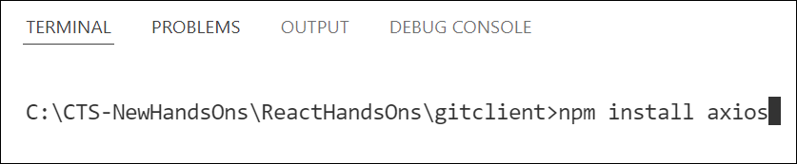
Figure 2: Install axios library
- Create a new file with the name as GitClient.js in src folder of the application
- Add the following code to create a class named GitClient which will make calls to the api.github.com to fetch the repositories as follows.

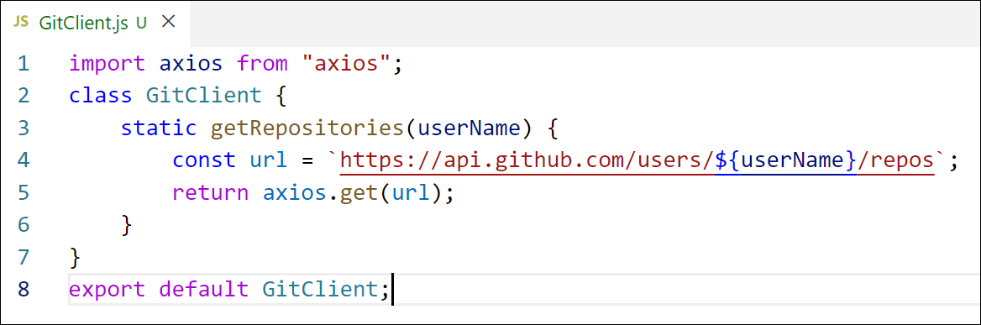
Figure 3: GitClient module
- Modify the App component to use the declared module to fetch and display the repositories data as follows.

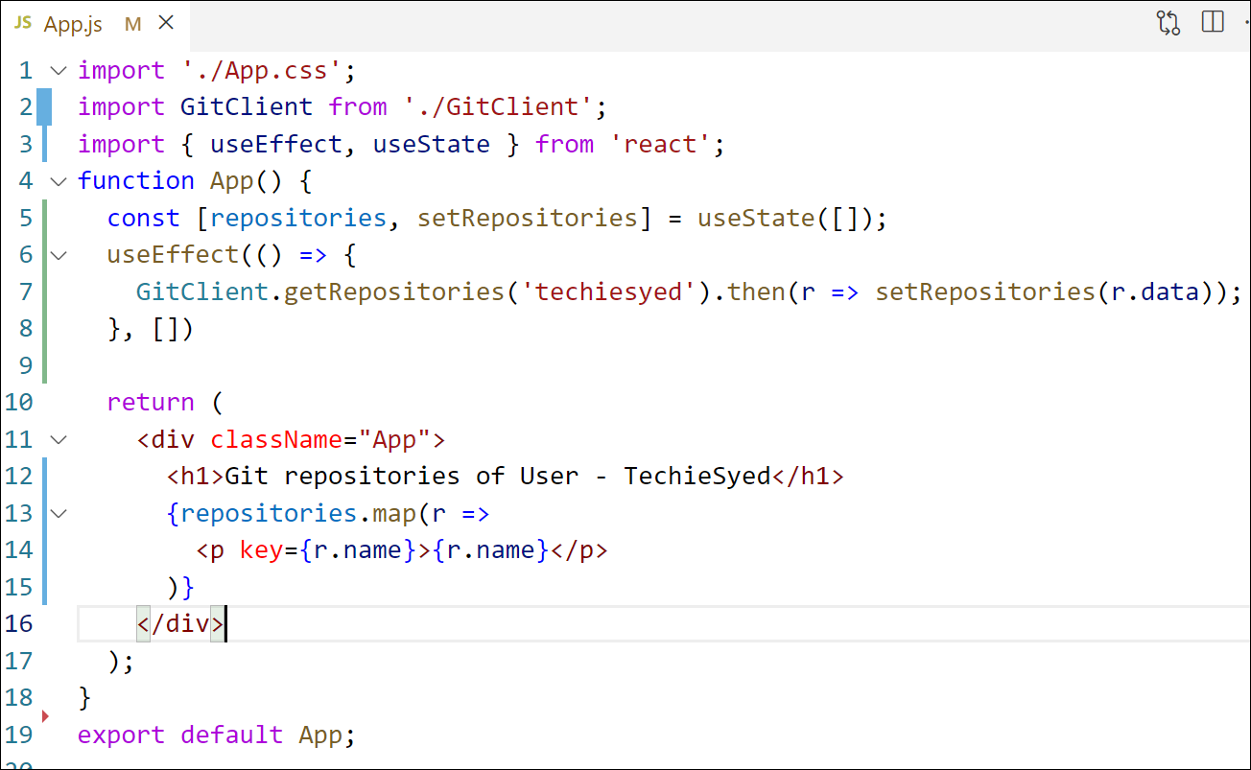
Figure 4: App Component
- Build and Run the application using npm start command. The output should look similar to below.
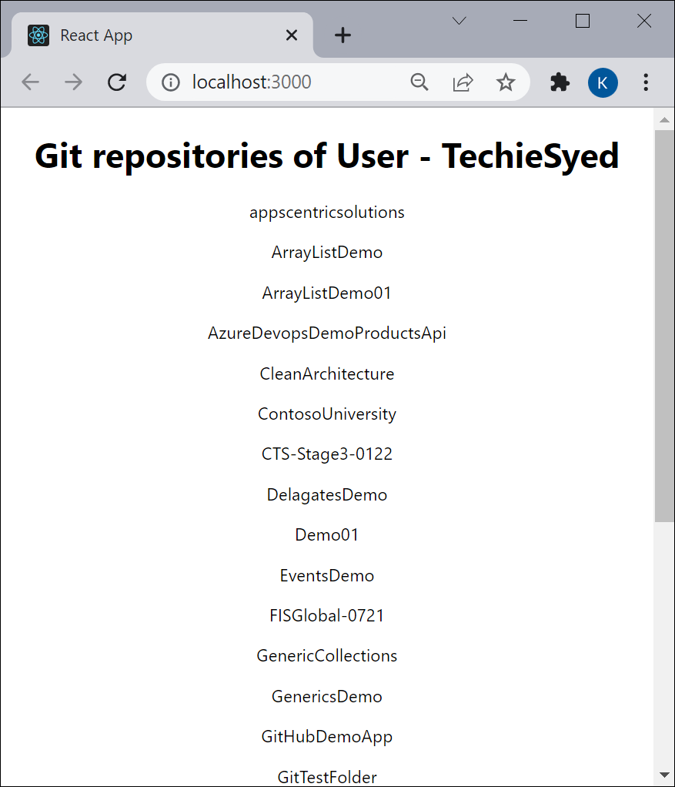
Figure 5: Application Output
- Create a new unit test file named as GitClient.test.js to unit test the newly created module.
- Import axios and GitClient into the unit test file.
- Describe the test name as “Git Client Tests”
- Create a unit test using the test() and give the test name as “should return repository names for techiesyed”
- Mock the axios object to return the dummy data
- Invoke the getRepositories() method of GitClient and see it’s returning the mocked data instead of making an actual call to api.github.com
- Run tests using npm test command.

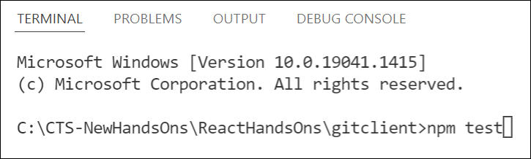
Figure 6: Run tests

